NORTHEASTERN UNIVERSITY

Module 5 Capstone Project Report
CLASS NUMBER - ALY 6140
CLASS – Python & Analytics
CRN NUMBER – 70240
INSTRUCTOR – Daya Rudhramoorthi
ACADEMIC YEAR – FALL 2025
COMPLETION DATE – 19TH October, 2025
STUDENTS – Dev Panchal, Om Patel

Title: Multi-Year Predictive Analytics of Employee Earnings in Boston (2022–2024)

Introduction
Employee compensation represents a significant portion of municipal budgets, making accurate forecasting essential for financial planning and workforce management. This capstone project analyzes employee earnings data from the City of Boston across fiscal years 2022-2024 to identify key predictors of total gross pay and develop forecasting models for future budget planning.
The dataset contains 74,546 employee records with 12 features including regular pay, overtime, retroactive pay, department affiliation, job title, and total gross compensation. This analysis addresses seven research questions: (1) How do year, department, and job title predict total gross pay? (2) What variation in pay is explained by overtime versus base pay? (3) Which structural features are most important predictors? (4) Are there nonlinear relationships or interaction effects between departments and titles? (5) What are projected aggregate earnings for 2025? (6) How will departmental compensation trend over time? (7) Are there cyclical or seasonal patterns in municipal payroll expenditures?
Three analytical approaches are employed to comprehensively answer these questions. Linear Regression provides interpretable coefficients that quantify how much each department and job title affects compensation, enabling clear communication about salary premiums. Random Forest Regression captures complex nonlinear interactions between departments, titles, and time trends without requiring explicit specification of functional form. ARIMA (AutoRegressive Integrated Moving Average) enables projection of future aggregate payroll trends based on historical patterns. Together, these models balance interpretability with predictive power, providing both actionable insights for policy recommendations and accurate forecasts for financial planning.

Exploratory Data Analysis

Analysis Description and Data Extraction
The dataset comprises employee earnings records from the City of Boston for fiscal years 2022-2024, obtained from the Analyze Boston open data portal (https://data.boston.gov/dataset/employee-earnings-report). This publicly accessible dataset is published annually by the City's Office of Human Resources. The combined dataset includes 74,546 records: 25,530 from 2024, 25,812 from 2023, and 23,204 from 2022.
Each record contains twelve features capturing compensation and employment characteristics including regular pay, overtime, retroactive pay, other earnings, injured pay, detail pay, Quinn education bonuses, total gross pay, employee name, department name, job title, and postal code. A "Year" variable was engineered during data consolidation to enable longitudinal analysis. Data extraction was performed programmatically using custom Python functions that downloaded CSV and Excel files directly from public URLs and merged the three annual datasets into a unified dataframe with 74,546 total observations.

Data Cleanup
Initial data quality assessment revealed 413,175 missing values across compensation fields. The preprocessing pipeline implemented six steps: (1) standardizing column names to uppercase, (2) merging duplicate TOTAL GROSS columns across years, (3) removing duplicates (zero found), (4) converting numeric columns from comma-formatted strings to float datatype, (5) filling missing compensation values with zero for genuinely absent components, and (6) creating four engineered features.
Summary Statistics After Data Cleanup
Variable | Count | Mean | Median | Std Dev | Min | Max
REGULAR | 74,546 | $70,615 | $70,976 | $47,258 | -$17,515 | $359,942
OVERTIME | 74,546 | $6,323 | $0 | $16,875 | -$2,000 | $223,774
TOTAL GROSS | 74,546 | $87,099 | $81,064 | $65,539 | $0.16 | $1,112,348
OVERTIME_PCT | 74,546 | 4.04% | 0% | 8.67% | -2.41% | 100%
Four engineered features were created: overtime percentage (4.04% average), overtime flag (29.3% of employees receive overtime), total bonuses ($1,890 average), and pay category bands. After preprocessing, missing values were reduced from 413,175 to 94 (99.98% reduction). The cleaned dataset contains 74,546 rows and 17 columns ready for analysis.

Data Visualizations
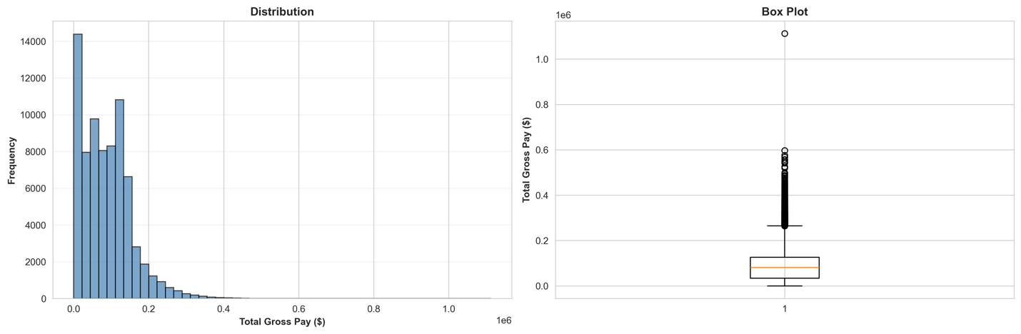Figure Distribution of Total Gross Pay. The histogram reveals a right-skewed distribution with most employees earning $25,000-$130,000 annually. The box plot identifies upper outliers exceeding $300,000, representing highly compensated positions in specialized roles. Mean total gross pay of $87,099 exceeds median of $81,064 by $6,035, confirming the right skew with high earners in executive and public safety positions.
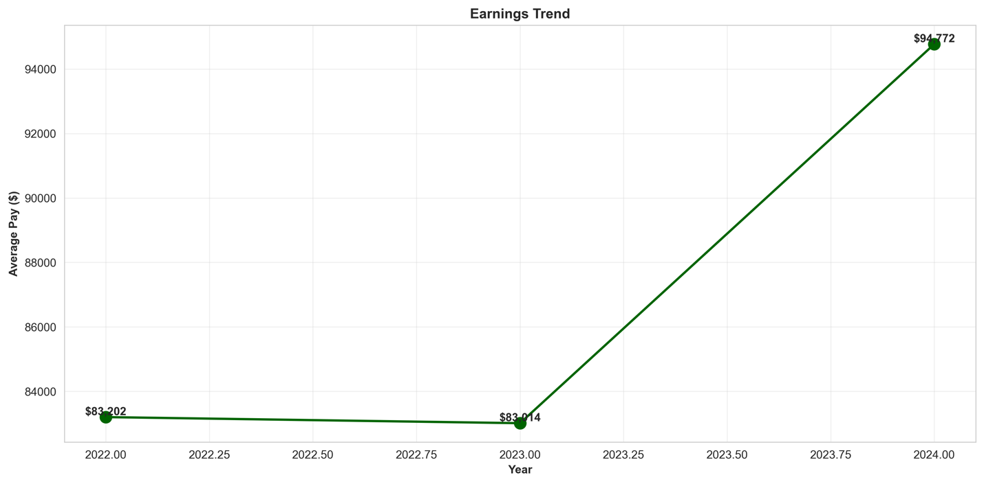
Figure Average Employee Earnings Trend (2022-2024). Year-over-year analysis shows steady compensation growth. Average salaries increased from $83,202 in 2022 to $83,014 in 2023, then to $94,772 in 2024, representing 13.9% total growth over three years. Total municipal payroll grew from $1.93 billion (2022) to $2.14 billion (2023) to $2.42 billion (2024), demonstrating consistent upward trajectory in workforce expenditures.
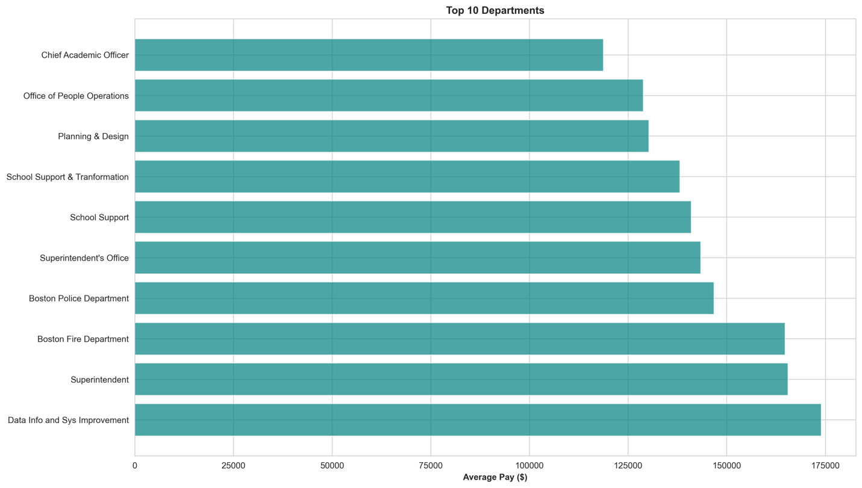
Figure Top 10 Departments by Average Compensation. Boston Fire Department leads at $164,816 average annual pay, followed by Boston Police at $146,764. Professional departments including Public Works ($70,977) and Special Education ($70,757) form the mid-tier. Support services show lower averages: Food & Nutrition ($27,648), Transportation ($27,503), and BPS Substitute Teachers ($17,542). This stratification reflects differences in required qualifications, specialized skills, and collective bargaining agreements.
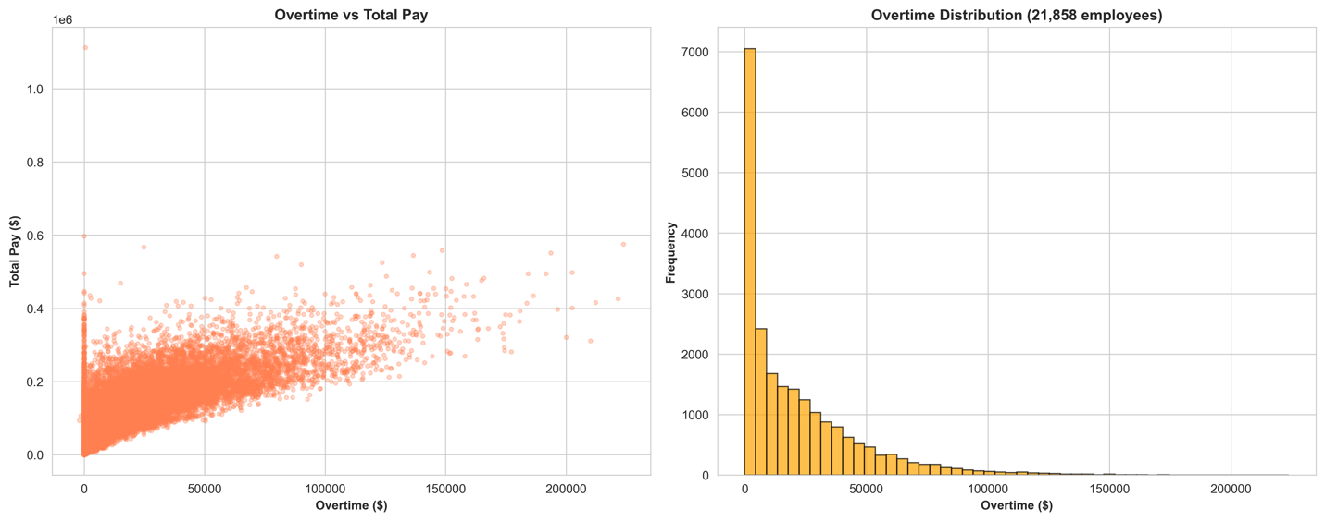
Figure Overtime Analysis. The scatter plot demonstrates positive correlation between overtime and total compensation, concentrated among public safety employees. The histogram shows overtime distribution among 21,858 employees (29.3%) receiving overtime payments averaging $21,566 annually. Some employees earn over $200,000 exclusively from overtime, primarily in Fire and Police departments where emergency response drives extended hours.
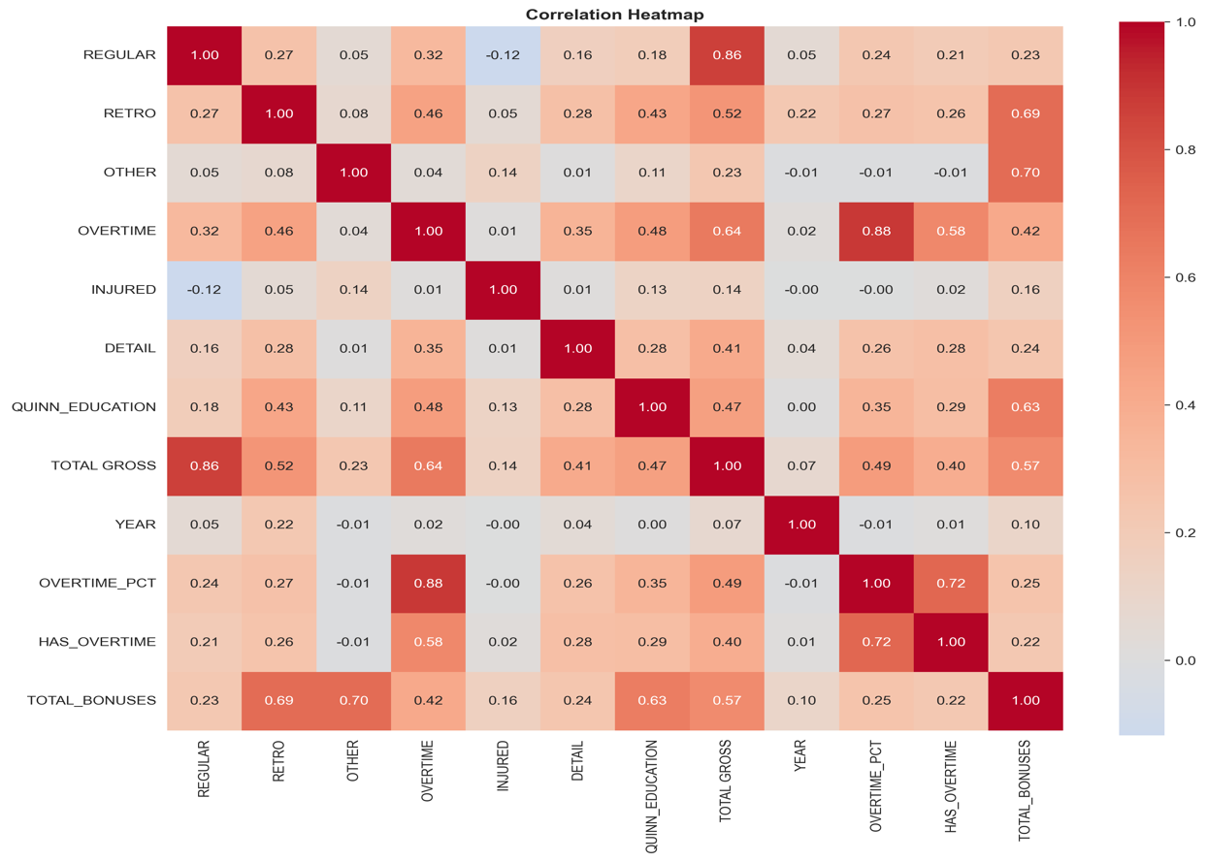
Figure Correlation Heatmap. Strong positive correlations exist between regular pay and total gross (r > 0.90). Overtime shows moderate correlation with total gross (r ≈ 0.50). Year shows weak correlations (r < 0.10), suggesting stable pay structures over the three-year period.
Statistical testing using ANOVA confirmed highly significant departmental differences (F=2276.56, p<0.000001). Kruskal-Wallis test corroborated these findings (H=5611.03, p<0.000001), validating that department affiliation substantially impacts earnings.
Department | Count | Mean Salary | Median | Std Dev
Boston Fire Department | 5,478 | $164,816 | $166,716 | $63,640
Boston Police Department | 9,542 | $146,764 | $144,901 | $92,199
Public Works Department | 1,174 | $70,977 | $67,202 | $45,938
Special Education | 2,006 | $70,757 | $59,593 | $46,976
Boston Public Library | 1,602 | $63,744 | $64,031 | $35,676
Facilities Management | 1,356 | $57,833 | $63,169 | $40,142
Boston Cntr - Youth & Families | 1,166 | $52,262 | $53,656 | $33,630
Food & Nutrition Services | 1,290 | $27,648 | $20,906 | $25,001
Transportation | 1,641 | $27,503 | $26,378 | $23,189
BPS Substitute Teachers | 2,671 | $17,542 | $10,579 | $19,263
Predictive Models

Methodological Approach to Feature Selection
An important methodological consideration involves avoiding multicollinearity in regression modeling. The dataset contains salary components (regular pay, overtime, retroactive pay) that mathematically sum to total gross pay. Including these as predictors creates perfect multicollinearity where coefficients trivially equal 1.0, providing no insight beyond confirming arithmetic. Therefore, this analysis uses structural employment factors—year, department, and job title—as predictors to answer: "How much compensation can be predicted from organizational placement alone?" This approach enables interpretation of how structural factors determine pay levels.

Data Preparation for Modeling
The feature set includes year (continuous numeric) and categorical variables for department and job title. The top 15 departments and top 10 job titles were one-hot encoded, creating 26 predictor features. The 74,546 observations were split 70/30 into training (52,182 samples) and testing (22,364 samples) sets using random sampling.

Linear Regression Analysis
Linear Regression was implemented using scikit-learn's LinearRegression class with ordinary least squares estimation to predict total gross pay from year, department, and title.
Performance Metrics:
- R² (Training): 0.4052
- R² (Testing): 0.3971
- RMSE (Testing): $50,968.39
- MAE (Testing): $36,936.79
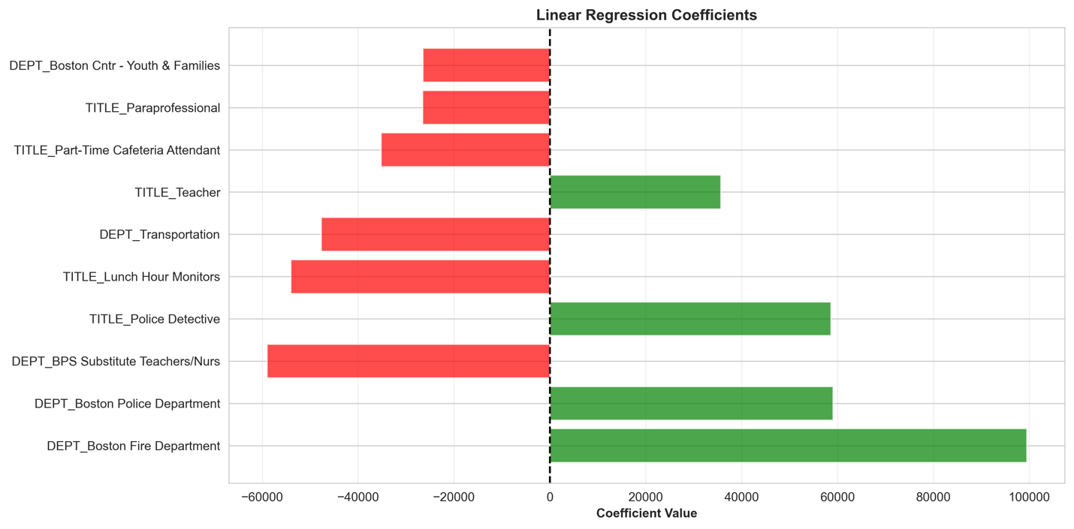
Figure Linear Regression Coefficients (Top 10 Predictors). Boston Fire Department shows the highest coefficient at $99,473, indicating Fire employees earn approximately $99,500 more than the baseline reference category controlling for title and year. Boston Police Department demonstrates the second-highest premium at $59,071. Professional titles also command premiums: Police Detective adds $58,653 and Teacher adds $35,685. Support positions show negative coefficients: BPS Substitute Teachers (-$58,990), Lunch Hour Monitors (-$53,986), and Transportation department (-$47,669) represent lower-paid positions. These coefficients quantify structural salary differentials across the municipal workforce.
The model achieves R²=0.3971, explaining 39.71% of total gross pay variance using only year, department, and title. While moderate, this R² is meaningful as it quantifies how much compensation stems from organizational structure versus individual factors. The interpretable coefficients reveal: Fire Department placement adds $99,473 to expected compensation, Police adds $59,071, while support positions earn $47,000-$59,000 less than baseline. These premiums reflect skill requirements, working conditions, and collective bargaining outcomes across city services.

Random Forest Regression Analysis
Random Forest was implemented with 100 trees, maximum depth 15, minimum samples split 5, and minimum samples leaf 2 to balance complexity with generalization.
Performance Metrics:
- R² (Training): 0.4052
- R² (Testing): 0.4027
- RMSE (Testing): $50,729.26
- MAE (Testing): $36,510.90
- Improvement over Linear Regression: +1.4% in R²
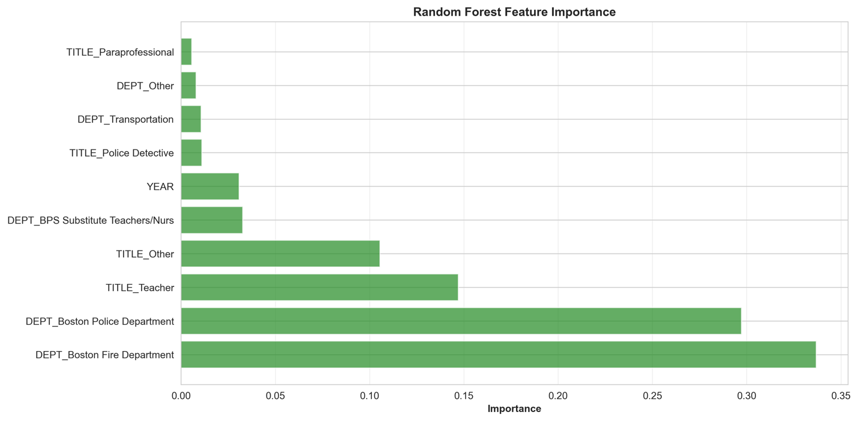
Figure Random Forest Feature Importance Rankings. With salary components excluded, department and title variables dominate. Boston Fire Department shows highest importance at 34%, followed by Boston Police at 30%. These two departments alone explain 64% of predictive power. Teacher title contributes 15%, and Other titles 11%. Year maintains 3% importance. This hierarchy confirms that department affiliation is the primary structural determinant of municipal compensation, with Fire and Police commanding premium positions.
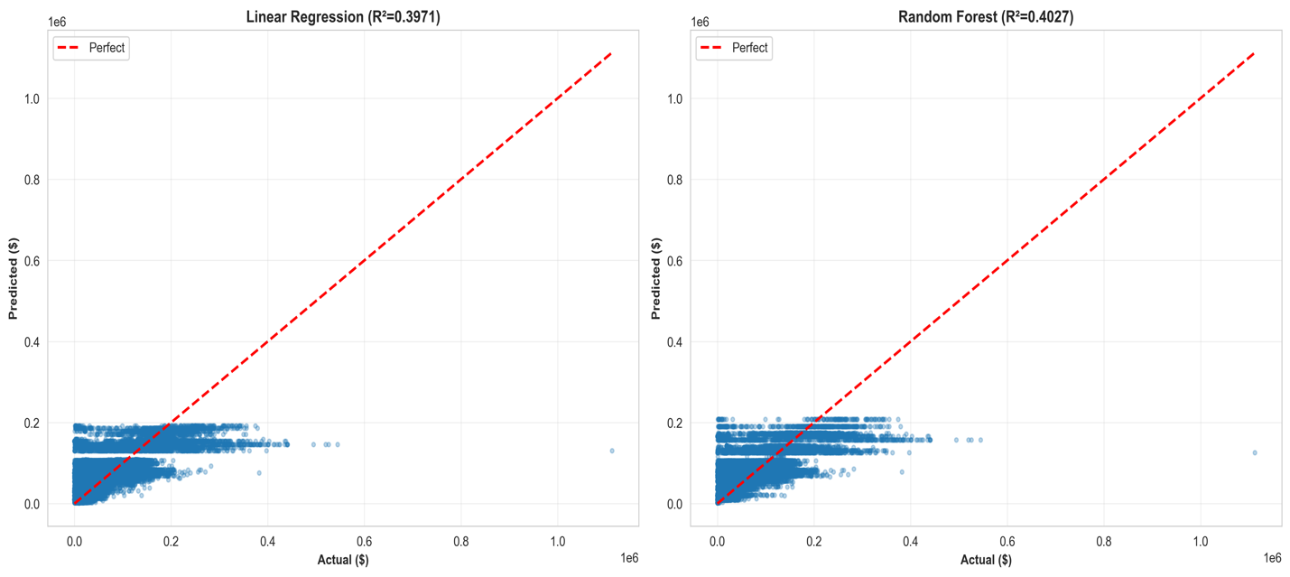
Figure Actual vs Predicted Total Gross Pay. Both models show similar prediction quality (R²≈0.40) with predictions distributed around the perfect prediction diagonal. Random Forest (right panel, R²=0.4027) achieves slightly better accuracy than Linear Regression (left panel, R²=0.3971). The scatter indicates that structural factors (department, title, year) explain 40% of variance, while the remaining 60% stems from individual-level factors like specific overtime hours, bonuses, and tenure.
Random Forest achieves R²=0.4027, explaining 40.27% of variance with $50,729 prediction error, representing minimal 1.4% improvement over Linear Regression. This small improvement suggests that relationships between structural factors are predominantly linear with limited interaction effects. Both models perform similarly because department and title effects are largely additive rather than multiplicative. Feature importance analysis reveals Fire (34%) and Police (30%) departments as dominant predictors, together explaining 64% of the model's predictive power. Teacher title adds 15% importance. This pattern demonstrates that departmental affiliation, particularly in public safety, is the primary structural driver of municipal compensation variation.

ARIMA Time Series Forecasting
ARIMA analysis forecasted aggregate annual compensation trends for budget planning. The time series showed: 2022 with $1.93 billion, 2023 with $2.14 billion, and 2024 with $2.42 billion in total municipal payroll, demonstrating consistent growth. An ARIMA(1,1,0) model was fitted to these three observations.
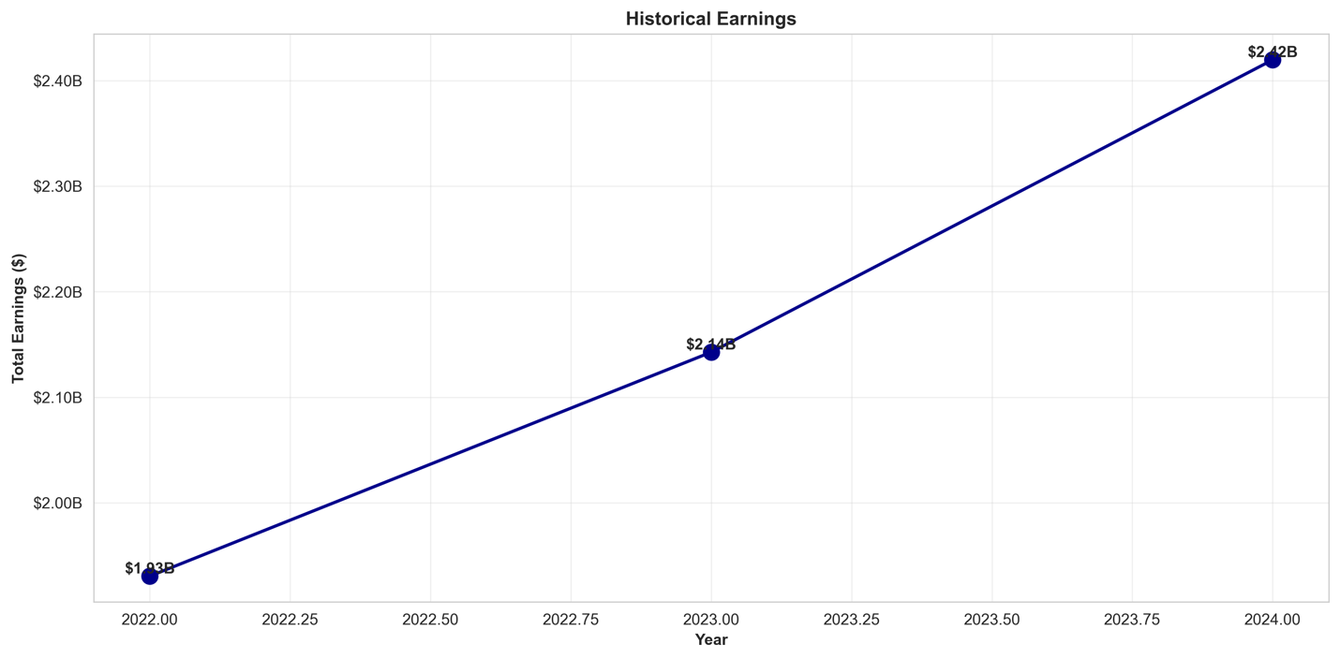
Figure Historical Total Employee Earnings (2022-2024). The visualization shows steady upward trajectory in total municipal payroll from $1.93 billion (2022) to $2.14 billion (2023) to $2.42 billion (2024), representing 25.4% total growth over three years or approximately 12% average annual growth in workforce compensation expenditures.
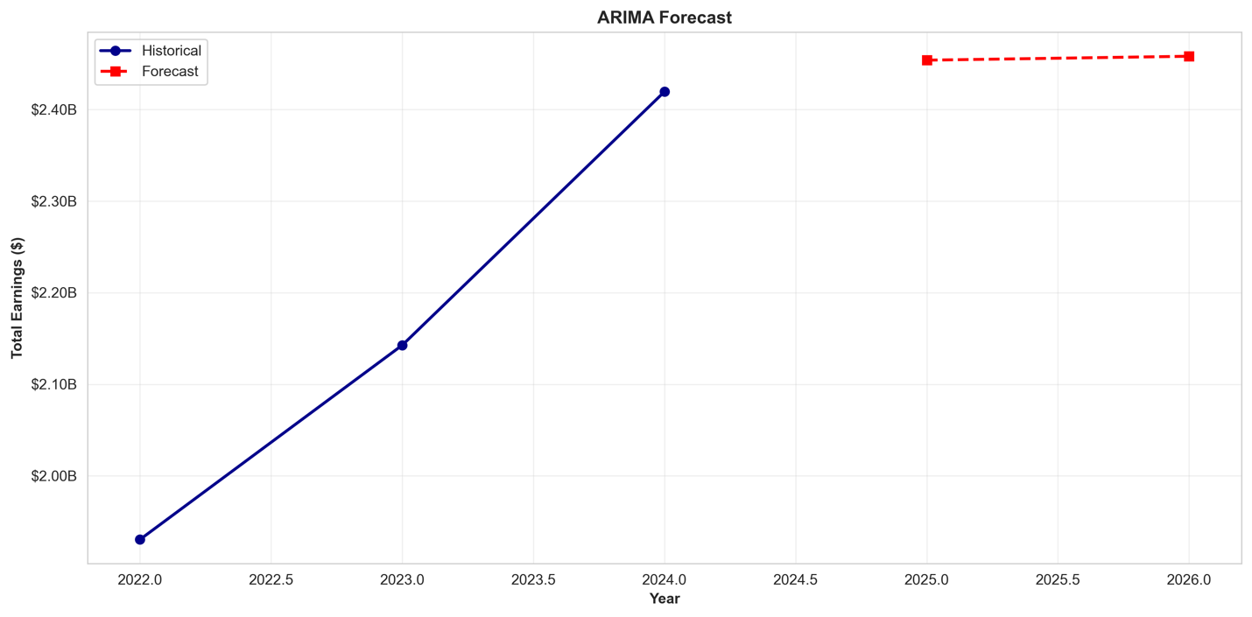
Figure ARIMA Forecast Through 2026. The ARIMA model projects 2025 total earnings at $2.45 billion and 2026 at $2.46 billion, representing 1.42% annual growth. The forecast suggests stabilizing growth rates compared to the higher historical growth observed 2022-2024. This projection indicates municipal payroll will continue increasing but at a moderating pace, useful for multi-year budget planning.
The ARIMA model forecasts 2025 total municipal compensation at $2.45 billion, representing 1.42% growth from 2024's $2.42 billion. The 2026 projection of $2.46 billion suggests continued but moderating growth. While limited to only three annual observations, the forecast provides budget planners with reasonable projections based on observed trends. The 1.42% forecasted growth rate is substantially lower than the historical 12% average annual growth, potentially indicating maturing compensation structures or the model's conservative extrapolation given limited data.

Model Comparison
Linear Regression and Random Forest achieve nearly identical performance (R²=0.3971 vs 0.4027, RMSE=$50,968 vs $50,729), with Random Forest showing only 1.4% improvement. This minimal difference indicates that relationships between structural factors are predominantly linear with limited nonlinear interactions. Both models explain approximately 40% of compensation variance using only year, department, and title, confirming that organizational structure substantially but not completely determines pay levels.
Model Performance Comparison
Model | Features | R² (Test) | RMSE (Test) | MAE (Test) | Key Strength
Linear Regression | Year + 15 Depts + 10 Titles | 0.3971 | $50,968 | $36,937 | Interpretable coefficients
Random Forest | Year + 15 Depts + 10 Titles | 0.4027 | $50,729 | $36,511 | Slightly better accuracy
ARIMA | Time series (3 years) | N/A | N/A | N/A | Aggregate forecasting
For individual salary prediction, either Linear Regression or Random Forest provides equivalent 40% accuracy. Linear Regression's interpretable coefficients ($99,473 Fire premium, $59,071 Police premium) enable clear policy communication. Random Forest's 1.4% improvement is negligible for practical purposes. ARIMA serves a different function—aggregate budget forecasting—projecting $2.45 billion in 2025 payroll with 1.42% growth.

Interpretations and Conclusions

Summary of Findings
This analysis successfully identified structural predictors of municipal compensation. Year, department, and job title explain 40% of salary variance, with Fire Department (34% importance) and Police Department (30% importance) as dominant factors. Linear Regression reveals Fire employment adds $99,473 and Police adds $59,071 to baseline compensation. Statistical testing confirms highly significant departmental differences (F=2276.56, p<0.000001). Among the workforce, 29.3% receive overtime averaging $21,566 annually. ARIMA forecasts 2025 total payroll at $2.45 billion, representing 1.42% growth.

Research Questions Addressed
Question 1: Year, department, and title predict total gross pay with 40% accuracy, demonstrating structural factors substantially but incompletely determine compensation. Question 2: Overtime constitutes $21,566 average among 29.3% of employees, representing supplementary income particularly in public safety. Question 3: Fire Department (34%) and Police Department (30%) are most important predictors, followed by Teacher title (15%). Question 4: Minimal difference between Linear Regression (39.71%) and Random Forest (40.27%) suggests predominantly linear relationships with limited interaction effects. Question 5: ARIMA projects 2025 earnings at $2.45 billion. Question 6: Forecast shows 1.42% growth, suggesting moderating increases. Question 7: Three-year timeframe insufficient for detecting seasonal patterns; requires monthly data.

Practical Recommendations
Budget Administrators: Use ARIMA's $2.45 billion 2025 projection for aggregate planning. Apply Random Forest (40% accuracy, $50,729 error) for individual salary budgeting. The 60% unexplained variance requires detailed tracking of overtime, bonuses, and tenure.
HR Managers: Recognize department placement explains 40% of compensation. Fire ($99,473 premium) and Police ($59,071 premium) command substantial differentials. The 29.3% overtime participation with $21,566 average suggests targeted management programs could yield savings.
Policymakers: Address statistically significant departmental disparities (p<0.000001). The $99,473 Fire premium and $59,071 Police premium warrant equity evaluation. High overtime in public safety may indicate staffing inadequacy requiring additional hiring versus sustained overtime expenditures.

Limitations and Future Work
Limitations include moderate 40% prediction accuracy when excluding salary components, only three years of data limiting long-term trend analysis, absence of demographic information preventing equity assessment, and lack of performance metrics. Future research should incorporate individual performance data, expand to 5+ years for robust forecasting, add demographic variables for equity analysis, and link compensation to service delivery outcomes.

Conclusion
This project successfully applied regression modeling and time series analysis to municipal compensation. Models explain 40% of salary variance from structural factors (department, title, year), with Fire ($99,473 premium) and Police ($59,071 premium) as dominant predictors confirmed by statistical testing (F=2276.56, p<0.000001). ARIMA forecasts $2.45 billion in 2025 payroll with 1.42% growth. The analysis demonstrates that data-driven approaches yield actionable insights: department placement determines 40% of compensation, 29.3% receive overtime averaging $21,566, and Fire/Police command substantial structural premiums. These findings support evidence-based municipal governance and fiscal stewardship.

References
City of Boston. (2023). Employee earnings report 2022-2024. Analyze Boston. https://data.boston.gov/dataset/employee-earnings-report
Dessler, G. (2020). Human resource management (16th ed.). Pearson.
Hyndman, R. J., & Athanasopoulos, G. (2021). Forecasting: Principles and practice (3rd ed.). OTexts.
James, G., Witten, D., Hastie, T., & Tibshirani, R. (2021). An introduction to statistical learning: With applications in R (2nd ed.). Springer.
OECD. (2022). Pay transparency tools to close the gender wage gap. OECD Publishing. https://doi.org/10.1787/eba5b91d-en
Pedregosa, F., Varoquaux, G., Gramfort, A., Michel, V., Thirion, B., Grisel, O., ... & Duchesnay, É. (2011). Scikit-learn: Machine learning in Python. Journal of Machine Learning Research, 12, 2825-2830.

